File Dumper Manager

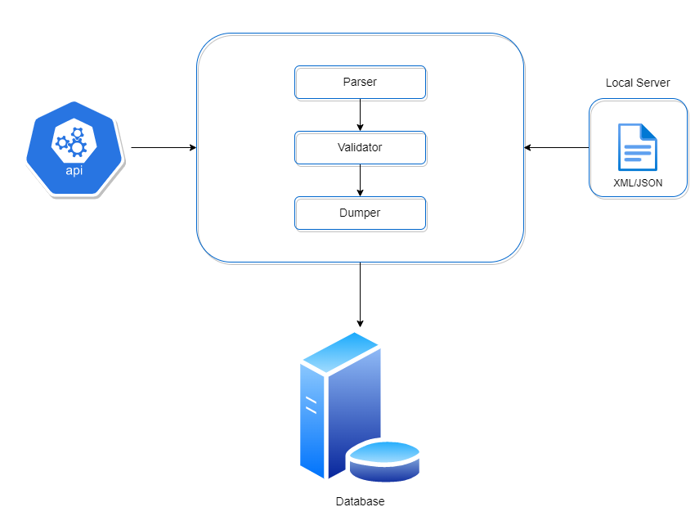
Figure 1 File Dumper Manager Architecture

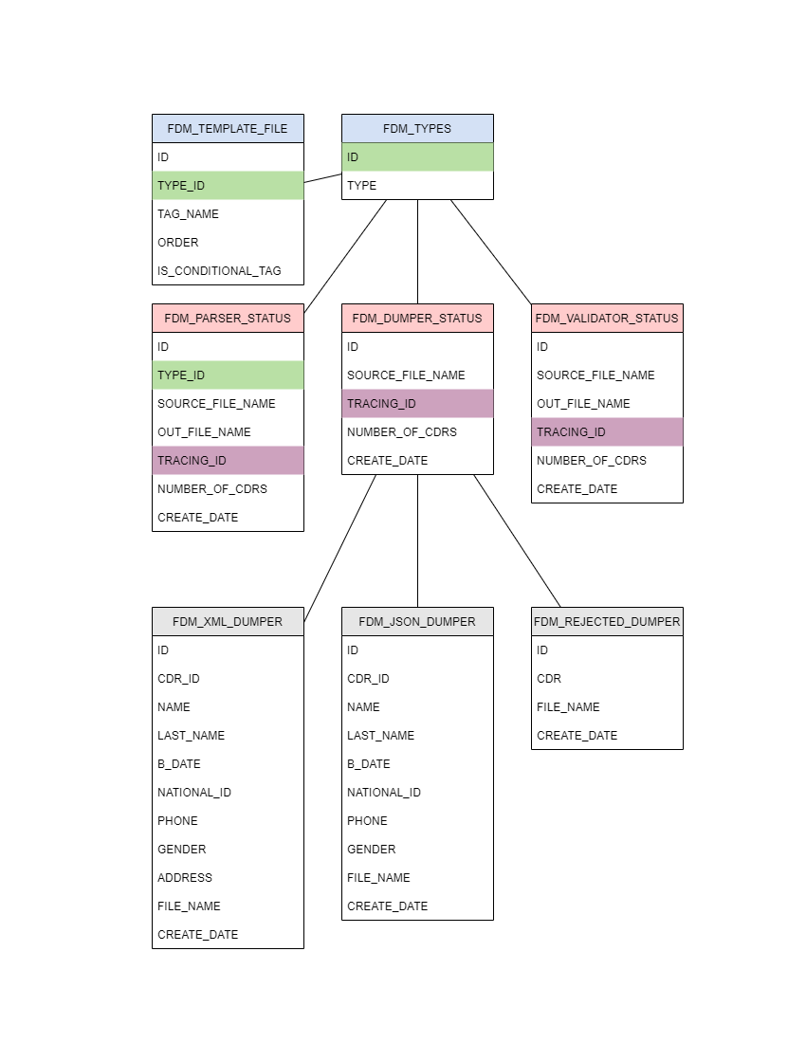
Figure 1 Database Architecture

Task Description:
File Dumper Manager System consists of three main components parser, validator and dumper.

- Parser:
  - Load properties file.
  - Load setup tables.
  - Fetch the files form source directory“./Source”.
  - Move the files to the destination directory “./Destination”.
  - Read the file and fill it in (List, Map or Set).
  - Convert the collection to csv file format (comma separated) “./Parser” and create new file with “.prs” extension.
  - Add the file name at the end of each CDR.
  - Rename the file after finish parsing to “.csv”.
  - Log the file into database “FDM_PARSER_STATUS”
  - Rename the files name in the destination directory by add “.DONE” at the end of the file.

Note: file format will be SOURCE_FILE_NAME-TRACING_ID.EXTENSION

- Validator:
  - Load properties file.
  - Load setup tables.
  - Fetch the files form “./Parser” that end with “.csv”.
  - Move the files to “./Validator”.
  - Generate new tow files “success and rejected” end with “.val”
  - Read the “.csv” file
  - Validate each CDR based on the “conditional tags” if exist in the CDR then should be add to the success file otherwise it will be added to the rejected file.
  - Rename the “success and rejected” files to be end with “.out”
  - Log the files into database “FDM_VALIDATOR_STATUS”
  - Remove “.csv” file.
Note: file format will be SUCCESS/REJECTED-TRACING_ID.EXTENSION

- Dumper:
  - Load properties file.
  - Load setup tables.
  - Fetch the files form “./Validator” that end with “.out”.
  - Move the files to “./Dumper”.
  - Read the “.out" file and Dump it into database
    - If the source file is JSON format you will dump the file CDR by CDR
    - If the source file is XML format you will dump the CDRs by batch.
  - Log the file into database “FDM_DUMPER_STATUS”
  - Remove the “.out” file

- Properties File:
The property file must have the below parameters:

  - Delimiter= ,
  - SourceFilePath=./Source
  - DestinationFilePath=./Destination
  - ParserFilepath=./Parser
  - ValidatorFilePath=./Validator
  - DumperFilePath=./Dumper
  - DatabaseIP=localhost
  - DatabasePort= 3306
  - DatabaseUser= username
  - DatabasePass= password
  - DatabaseSchema= training

- Data:
  - FDM_TYPES

ID | TYPES
1 | XML
2 | JSON

  - FDM_TEMPLATE_FILE

ID | TYPE_ID | TAG_NAME | ORDER | IS_CONDITIONAL_TAG
1 | 1 | ID | 1 | FALSE
2 | 1 | Name | 2 | FALSE
3 | 1 | LastName | 3 | FALSE
4 | 1 | BDate | 4 | FALSE
5 | 1 | NationalID | 5 | TRUE
6 | 1 | Phone | 6 | TRUE
7 | 1 | Gender | 7 | FALSE
8 | 1 | Address | 8 | FALSE
9 | 2 | ID | 1 | TRUE
10 | 2 | Name | 2 | FALSE
11 | 2 | LastName | 3 | FALSE
12 | 2 | BDate | 4 | FALSE
13 | 2 | NationalID | 5 | TRUE
14 | 2 | Phone | 6 | FALSE
15 | 2 | Gender | 7 | FALSE

- Source Files:
  - JSON
[
{
"ID": 12345,
"Name": "Peter",
"LastName": "Smith",
"BDate": "1992-10-23",
"NationalID": 123456789,
"Phone": "0788888888",
"Gender": "Male"
}
]

  - XML
<CDRS>
<CDR>
<ID>12345</ID>
<Name>Peter</Name>
<LastName>Smith</LastName>
<BDate>1992-10-23</BDate>
<NationalID>123456789</NationalID>
<Phone>0788888888</Phone>
<Gender>Male</Gender>
<Address>country, city, street...</Address>
</CDR>
</CDRS>

